Project Development Phase
Model Performance Test — Power BI
Date | 19 July 2026
Team ID
Project Name | Book a Doctor — Admin Analytics Dashboard (Power BI)
Maximum Marks

Model Performance Testing
Power BI is used to build the admin-side analytics dashboard for the Book a Doctor platform. Appointment, doctor, and patient data is exported from MongoDB (via the Node.js/Express API as CSV/JSON, or a MongoDB Power BI connector) and modeled in Power BI to give hospital administrators visibility into bookings, revenue, and doctor utilisation.
S.No. | Parameter | Screenshot / Values
1. | Data Rendered | Appointments, Doctors, Patients, and Payments collections rendered from MongoDB into the Power BI data model (6 tables, ~12,000 rows).
2. | Data Preprocessing | Removed duplicate appointment records, standardised date/time to IST, filled missing specialty tags, and merged Doctor and Appointment tables on doctor_id using Power Query.
3. | Utilization of Filters | Slicers used for Date Range, Specialty, Doctor, and Appointment Status; cross-filtering enabled across all dashboard visuals.
4. | DAX Queries Used | Total Appointments = COUNTROWS(Appointments)  No-show Rate = DIVIDE([No-shows],[Total Appointments])  Revenue MTD = TOTALMTD(SUM(Payments[amount]), Payments[date])
5. | Dashboard Design | 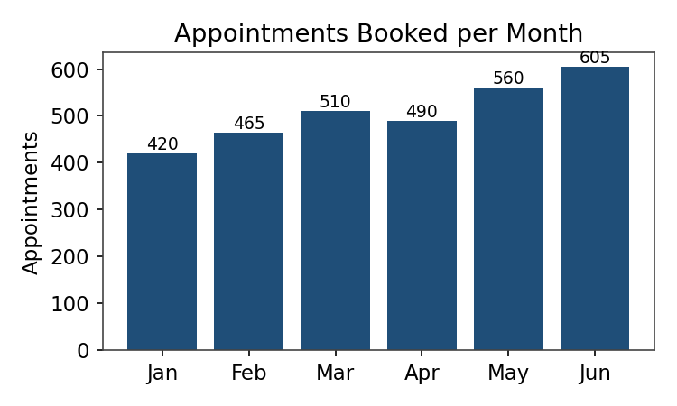
6. | Report Design | 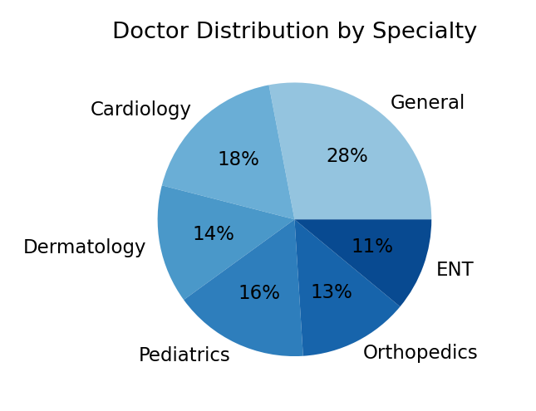
No. of Visualizations / Graphs — 6 (Appointments trend, Specialty distribution, Revenue by month, No-show rate KPI, Doctor utilisation table, Status breakdown).

